Year 9 – IGCSE 1 – Paper 2 May 2014 End of Year Exam Answers

1
2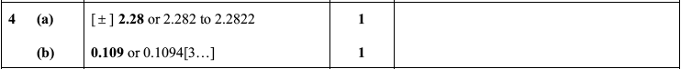
3
4
5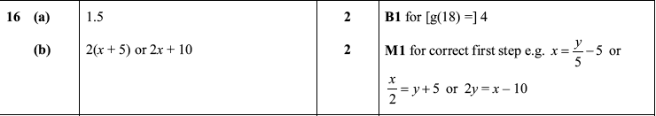
6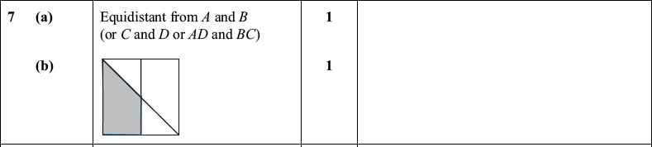
7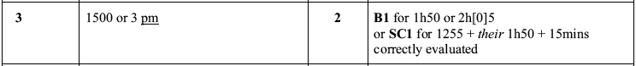
8
9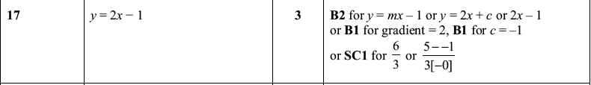
10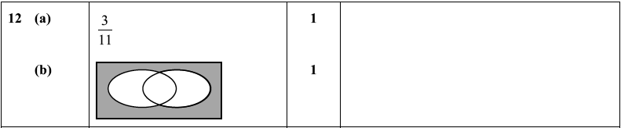
11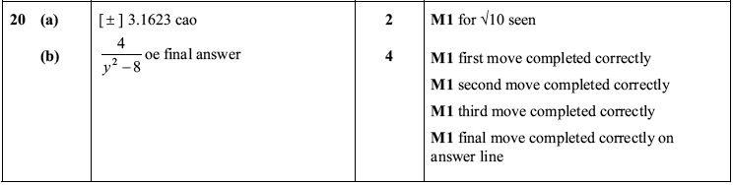
12
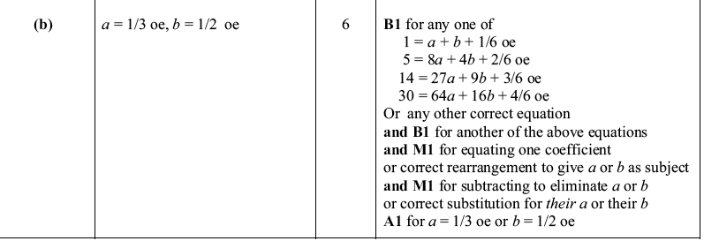
13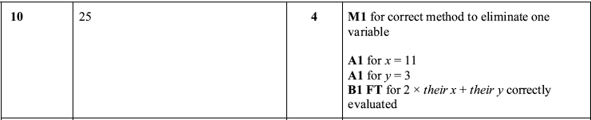
14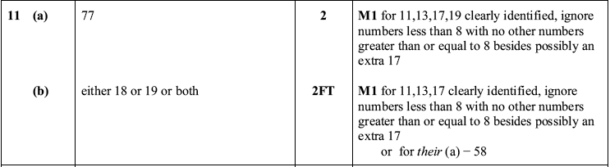
15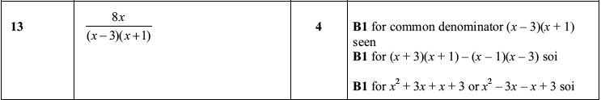
16