Year 10 – IGCSE 1 – Paper 2 May 2014 End of Year Exam Answers
1
2
3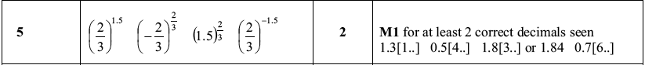
4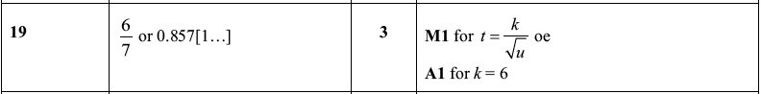
5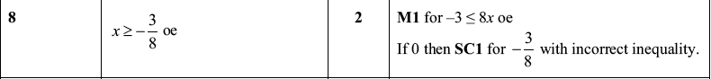
6
7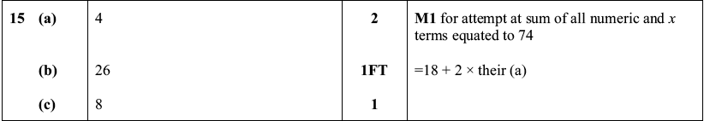
8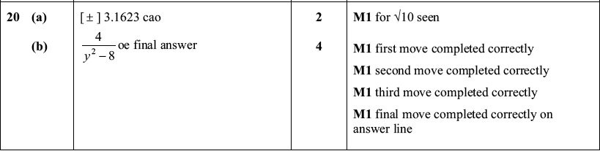
9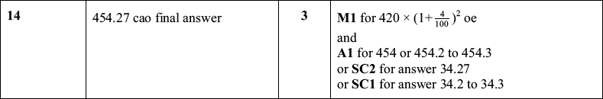
10
11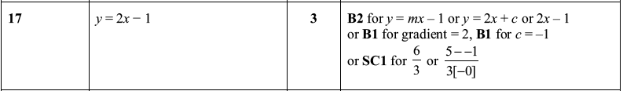
12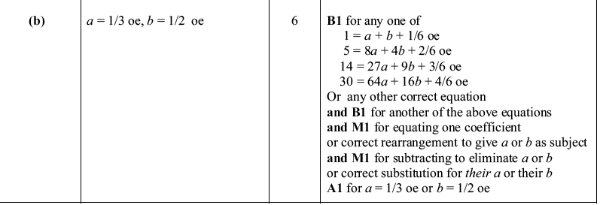
13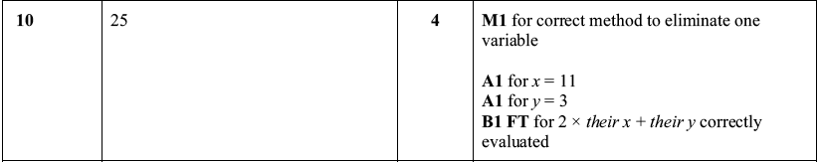
14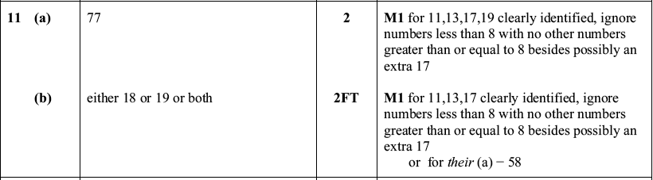
15
16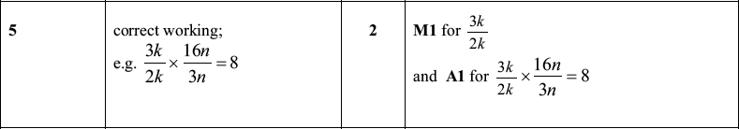
17

