IGCSE PYTHAGORAS/BEARINGS
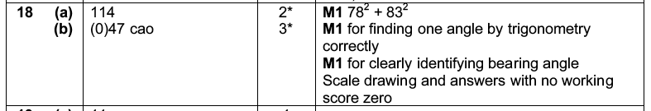

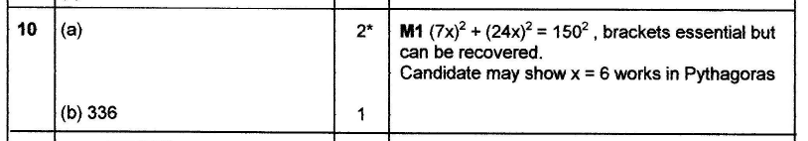
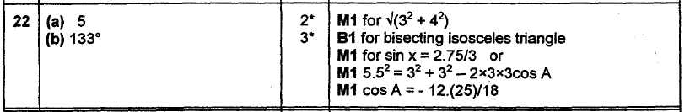
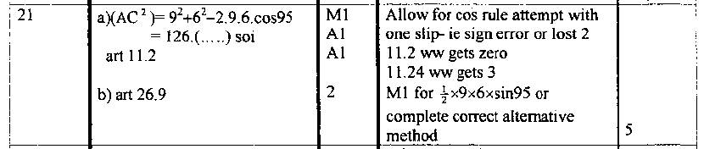
Trig/Pyth 1

Trig/pythag 2
Sine/cosine rule 1

Sine/cosine rule 1/bearings 2

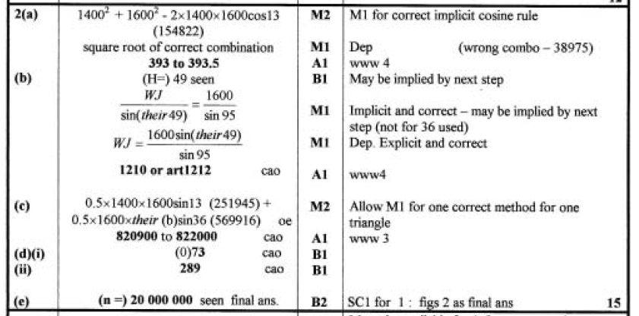
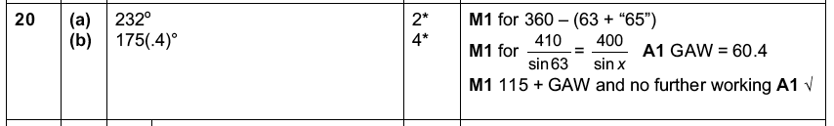
Sine/cosine rule 1/bearings 3

Sine/cosine rule 1/bearings/ elevation 4

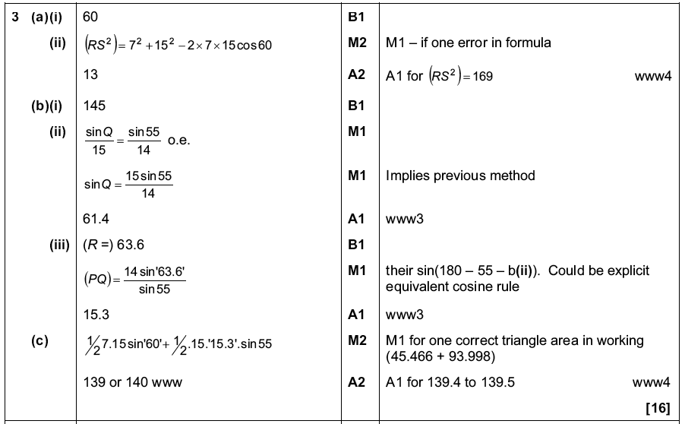
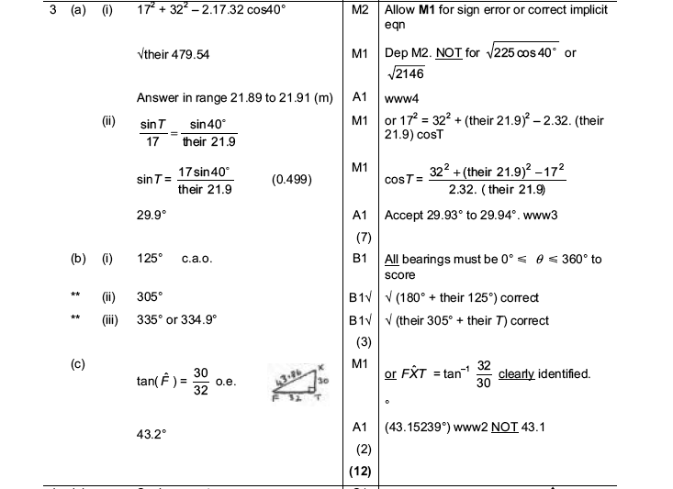

Sine/cosine rule 1/bearings/area 5

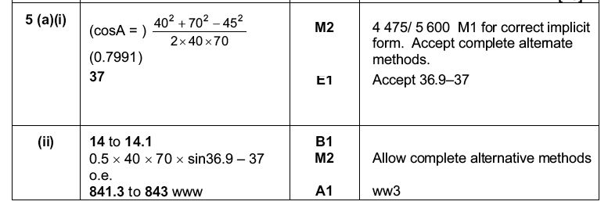
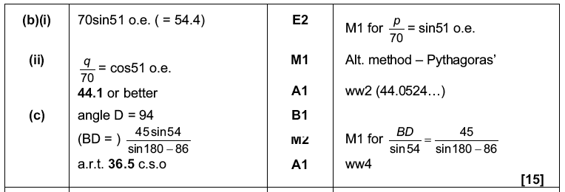
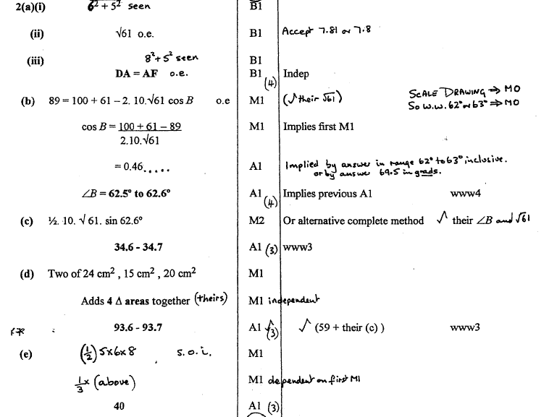
Sine/cosine rule 1/bearings/area/volume 6

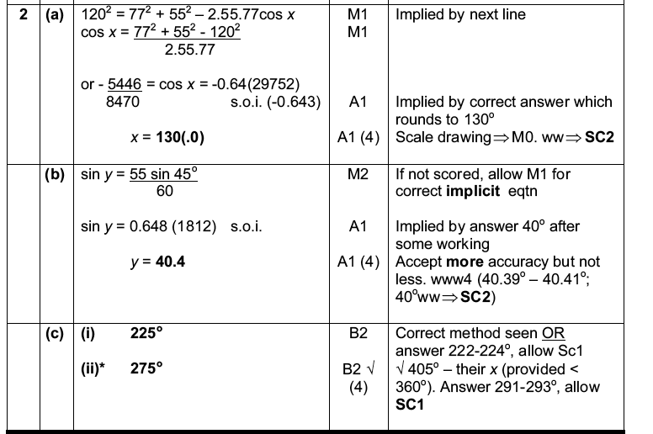
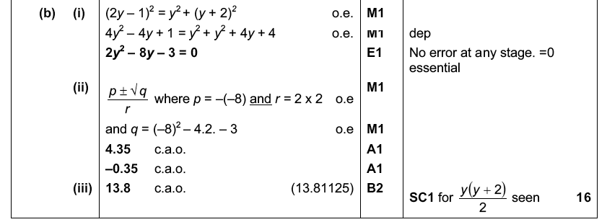
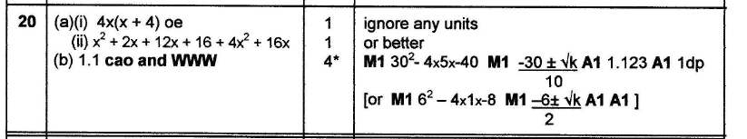
Applying the quadratic formula

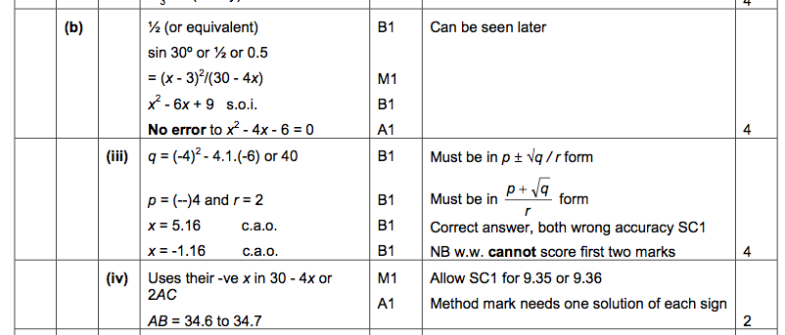
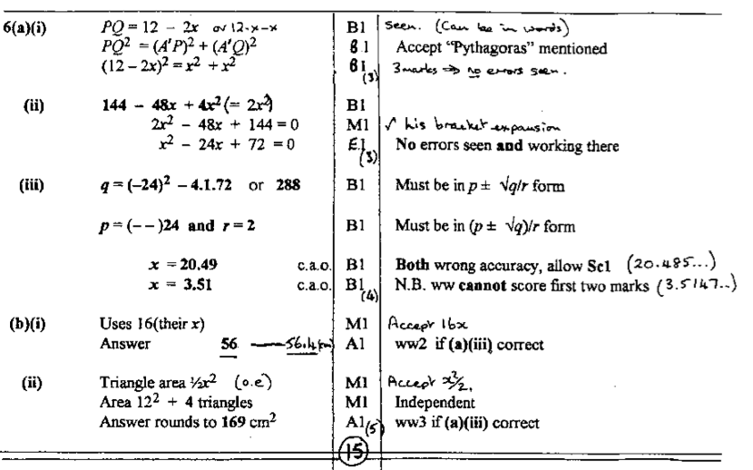
Pythag Quad Form

