Use a scientific calculator efficiently and apply appropriate checks of accuracy
Use text Book

Use current units of mass, length, area, volume and capacity and convert between units
7.5

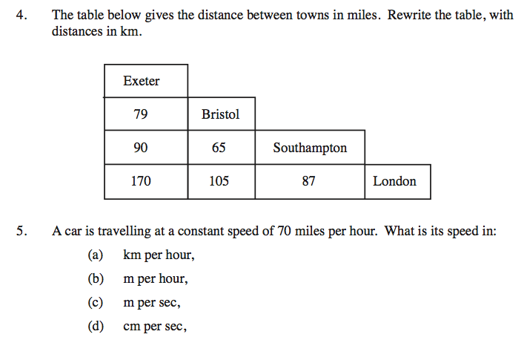
Calculate times in terms of 24-hour and 12-hour clock; read clocks, dials and timetables
8.1

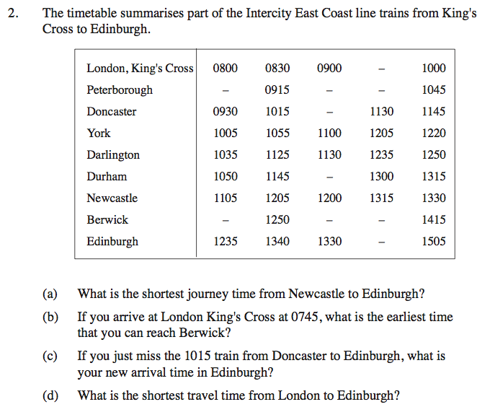

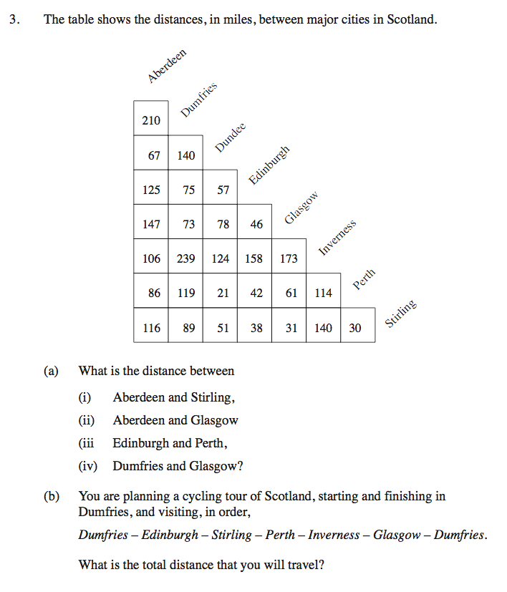

Divide a quantity into a ratio/Understand and use ideas and notation of ratio, direct and inverse proportion and measures of rate

15.2

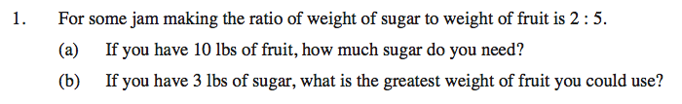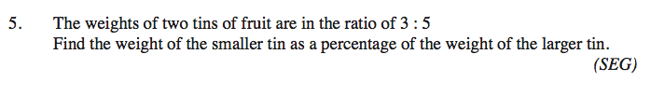

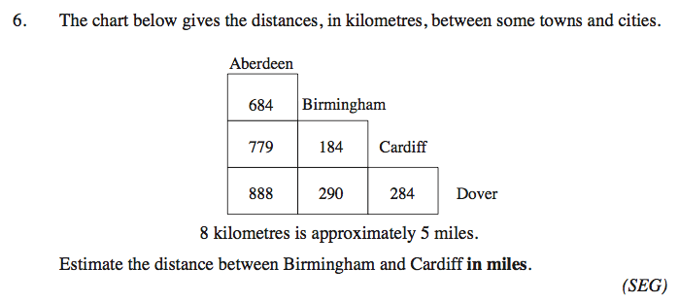
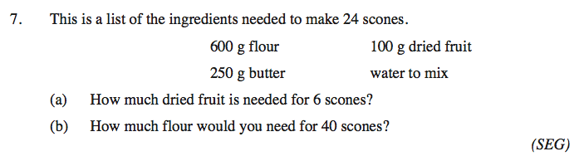
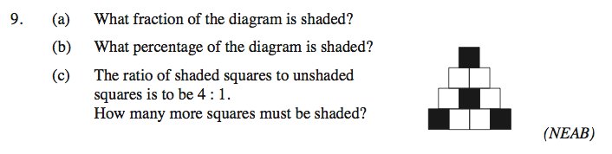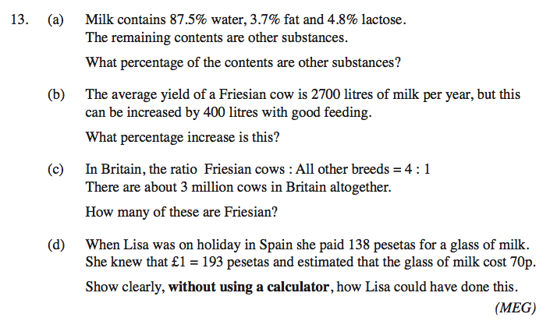
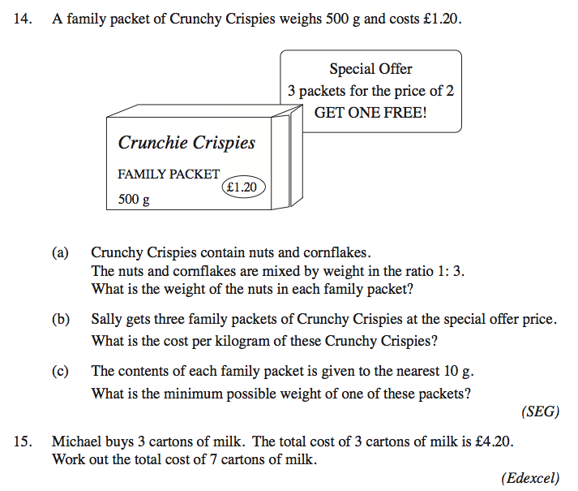
Use scales in practical situations
15.3

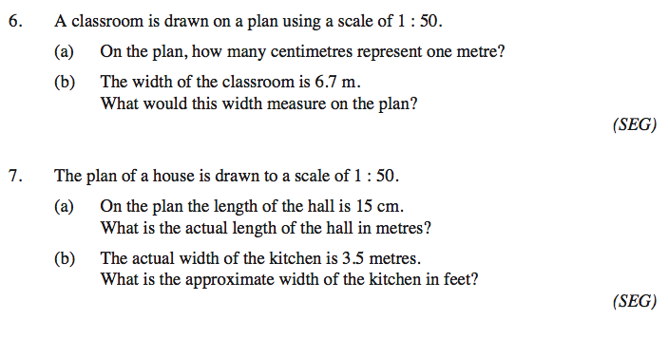

Express one quantity as a percentage of another
11.3
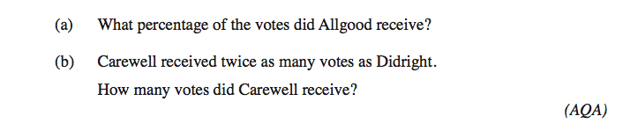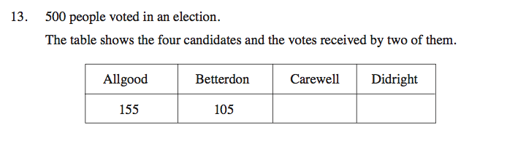
Carry out calculations involving reverse percentages
11.9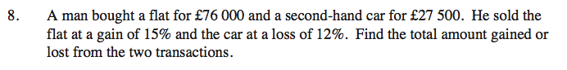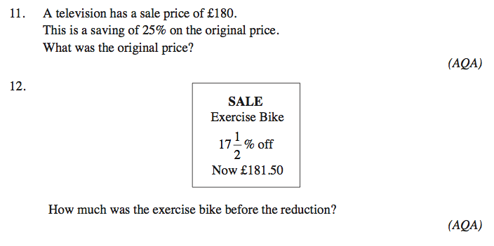
Calculate percentage increase and decrease
11.5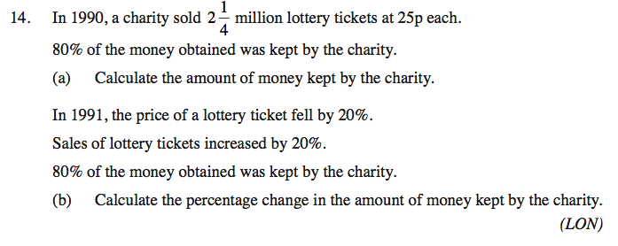
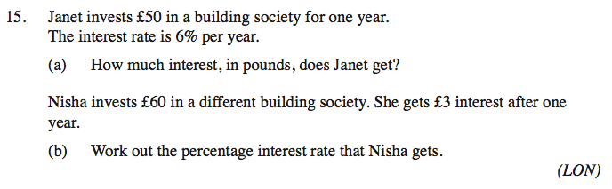
Calculate simple and compound interest
11.8
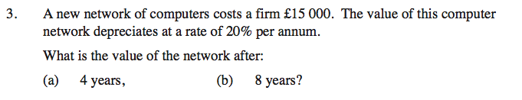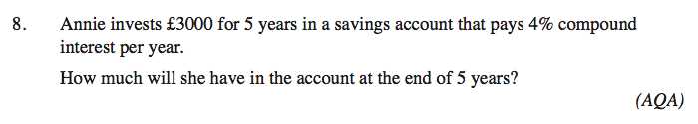
Use data to solve problems on personal and household finance involving earnings,
discount, profit and loss.
11.2
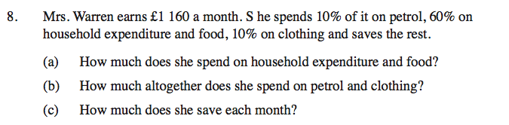

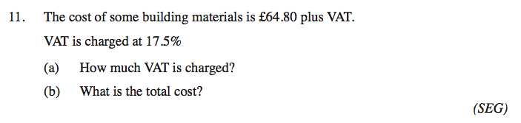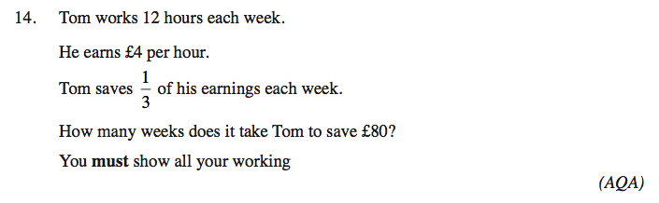
11.4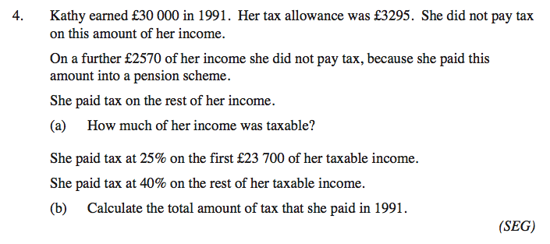
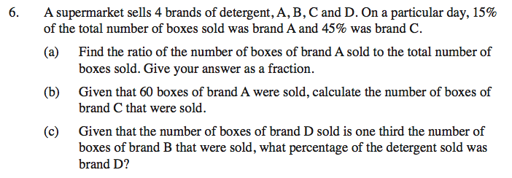
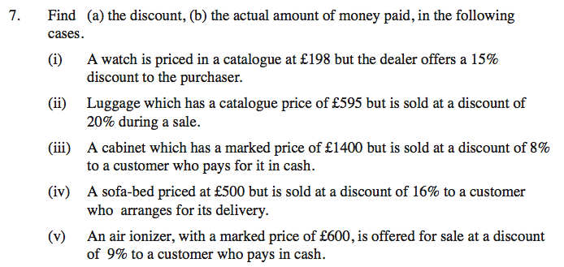
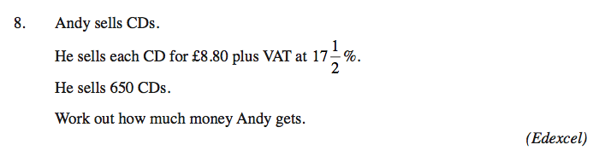
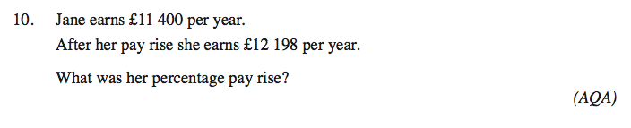
Calculate average speed – See text Book

Express direct and inverse variation in algebraic terms and use this to find unknown quantities
15.5

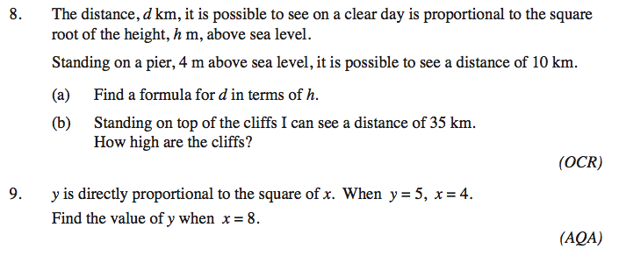

15.6
